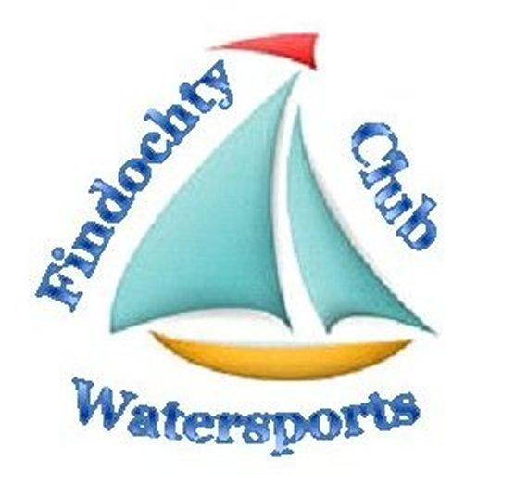
FINDOCHTY WATER SPORTS CLUB

MEMBERSHIP APPLICATION FORM

Name(s)

Address:

Postcode:

E-mail address:

(We no longer send out information by post, so it is important that we have your e-mail address.
If you have no email address please arrange with a member who has email to pass information.)

Telephone number:

EMERGENCY Telephone number:

Interests (Sailing/Fishing/Pleasure Boat/Skiff Rowing/Kayaks/Canoes/SUP Boards) – Please circle.

If boat owner - Type of Boat: Name of Boat:

Relevant Qualifications, if held (RYA Sailing/Motor – MCA Commercial - Coaching.)

Experience if Relevant:

MEMBERSHIP FEE COVERING CALENDAR YEAR COMMENCING 1 JANUARY

Please Circle: Individual £30 Family £40

Club Burgee (Optional – please circle if required) £10.00

Please return form to:
MOIRA BINGHAM
FWSC MEMBERSHIP SECRETARY
65 COMMERCE TREET
LOSSIEMOUTH
IV31 6QQ

I AGREE TO ABIDE BY THE CLUB CONSTITUTION AND TO THE INFORMATION I HAVE PROVIDED ON THIS FORM, TO BE HELD SECURELY, FOR THE SOLE PURPOSE OF COMMUNICATION WITHIN FINDOCHTY WATER SPORTS CLUB.

Signature:

DATE:

